Title (use capital letters)
1st author¹, 2nd author², … {presenter in bold}
¹ company/institution, city, COUNTRY of 1st author, ² company/institution, city, COUNTRY of 2nd author, …
Contact email address

Abstract
Write a short summary (150 words maximum) on the contents of your paper.
Keywords: e.g. Photometry, Colour Rendering, …

Section 1
This and the following sections and sub-sections shall serve as an example how to structure a paper.

Section 2
Section 2 is, as an example, subdivided in several subsections.

Section 2.1
Example for a figure:
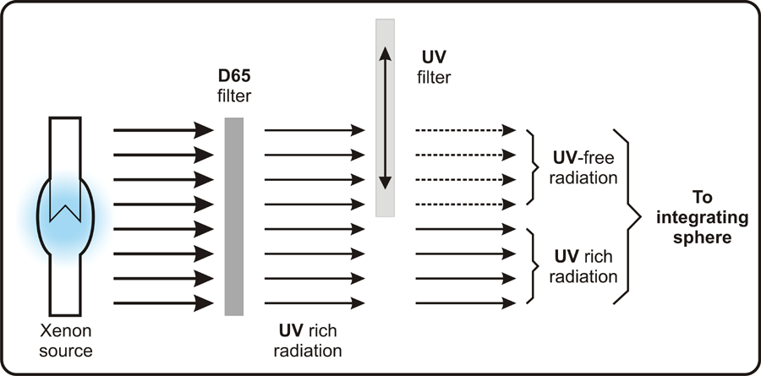
Figure 1 – Caption of Figure 1

Section 2.2
Example for a table:
Table 1 – Caption of Table 1
 | ISO 3664* | ASTM D1729* | JIS Z 8717** | BS 950
UV range | 0,44 | 0,44 | 1,09 | Within ±30 %
Visible range | 0,29 | 0,29 | 1,47 | Within ±15 %
Classification | Approved | Approved | Approved | Approved

Section 2.3
For listings use the following style:
- List item 1
- List item 2
- ……
…..
NOTE This is a note.

Subsection 2.4
Subsection 2.4 is, as an example, subdivided in further subsections.

Subsection 2.4.1
Text of Subsection 2.4.1.
.
.
.

Subsection 2.4.2
Text of Subsection 2.4.2.
.
.
.

Section 3
Text of Section 3
Example for an equation:
(1)
where
v is the speed of a point in uniform motion;
l is the distance travelled;
t is the duration.
.
.

References
For citations in the text please use Harvard style, i.e. state the first author or organization and the year of publication in brackets.
Minimum requirements for references:
For an article: Author’s family name (capital letters), initials(s) of the first name(s). Year of publication. Title of the article. Name of the journal (italic), volume (and issue) number, page numbers.
Example:
ADRIAN, W. 1989. Visibility of Targets: Model for Calculation. Lighting Res. Technol., 21, 181-188.
For a book: Author’s family name (capital letters), initials(s) of the first name(s). Year of publication. Title of the book (italic) (Page numbers if necessary). City of publication: Name of the publisher (if known).
Example:
BOYCE, P.R. 2003. Human Factors in Lighting, 2nd Ed. New York: Taylor and Francis.
For an official publication of an organization: Initials of the organization. Year of publication Title of the publication (italic). City of publication: Name of the publisher (if known).
Example:
CIE 2010. CIE 191:2010. Recommended System for Mesopic Photometry Based on Visual Performance. Vienna: CIE.

The author names should have the following style: family name, initial(s) of the first name(s), e.g. Smith, M.D.

